## horizontal line



Financial Analysis & Statistics

02.02.2021

**─**

Andriii Naidenko

# Overview

This project is a financial analysis web tools for expecting and statistics the several functions based on the previous data.

# Goals

1. To provide a financial analysis based on certain formula and data easily.
2. To provide several kinds of service in financial expectations based on analysis.
3. To provide graphs to show the clients visually which reflects several functions.
4. To provide reports.

# Motivations

This is your parts.

Danny KThai

# Milestones

This project can be divided several parts as following:

## 1. Preparation

1.1 Period: 40 ~ 60 hours

1.2 Description: Write a comprehensive documentation which describes features in the developing platform.

1.3 Content

* Architecture of the platform (divide into several stages and sub features).

The project architectures should be as scalable, maintainable, and well-structured.

* To clarify every stage/feature clearly step by step and predict issues in every stage.

To understand every formula step by step clearly and need to collaborate with financial experts or teams.

* Build a frontend Mockup by using Figma or Adobe Photoshop

We should hire a designer to build the mockup of this platform’s frontend side.

And check the Design, every screen and handle the feedbacks from the team.

Responsive designs for Desktop, Mobile, Tablet.

* To choose software packages and suits to use in the platform.

Examples

Engine python packages: pandas, pyplot and so on.

Backend side API in Web Dashboard: Django Rest Framework.

Frontend side Framework: React Framework, chat.js of React and so on.

Other settings: Docker for deployment.

* Define endpoints and URLs.

Examples:

<http://xxx.xxx/auth/login>

<http://xxx.xxx/auth/register>

<http://xxx.xxx/dashboard/>

<http://xxx.xxx/api/auth/login>

………………..

## 2. Development

2.1 Period: 8~10 weeks

2.2 Description: Carry out the project based on the documentation.

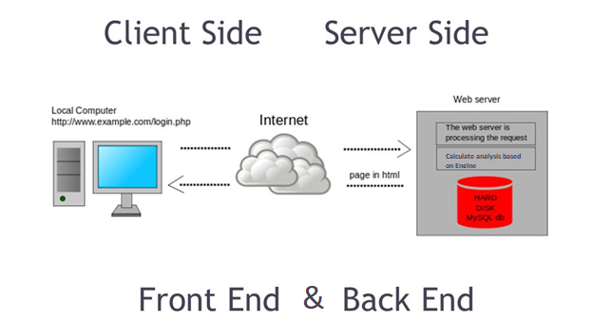

2.3 Contents

* DevOps (15~ 20 hours)

Create and initialize repository the project based on the document.

Download the software packages, set up the environments, make real structures of project such as creating of meaningful directories.

Set up other project settings such as Docker setup.

* Internal functions: Engine Development (About 2~3weeks)

Make the modules of every analysis functions based on test previous data

* Backend (2 weeks)

Implement the API entry-points in the backend-side integrated with internal functions and

Third-party API integrations.

* Frontend (2 weeks)

Make the front-end side pages based on Mock and integrated with Backend Side API.

* Testing, bug fixing, supporting (1 ~ 2 weeks)

First, we test by the auto testing functions